How to Safely Refill Isoflurane Reservoir

- When the imaging session is complete, depressurize the anesthesia system by turning off the Oxygen tank and all other anesthesia pump switches.
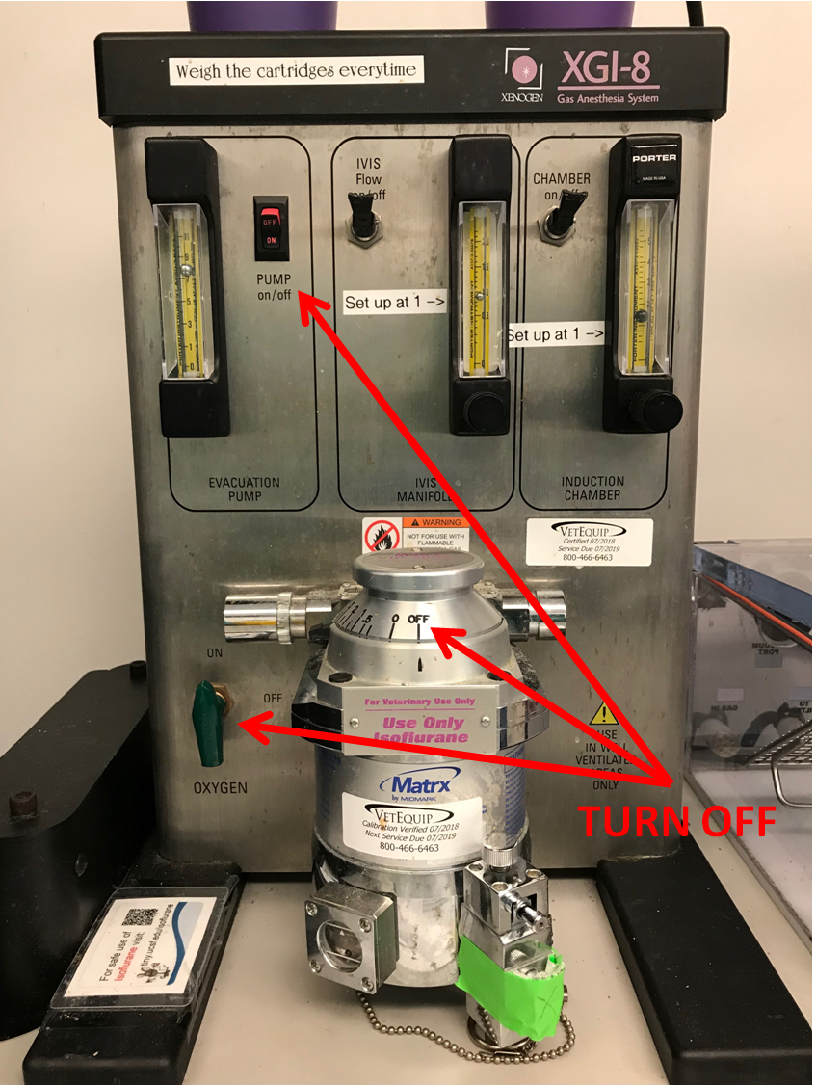
- Keep the IVIS Flow and Chamber levers open to release the pressure inside the anesthesia system.
- When the ball level drops to zero (the bottom of the gauge) and rests there for a couple seconds (see red arrows), the system should be de-pressurized enough to safely open the isoflurane reservoir. 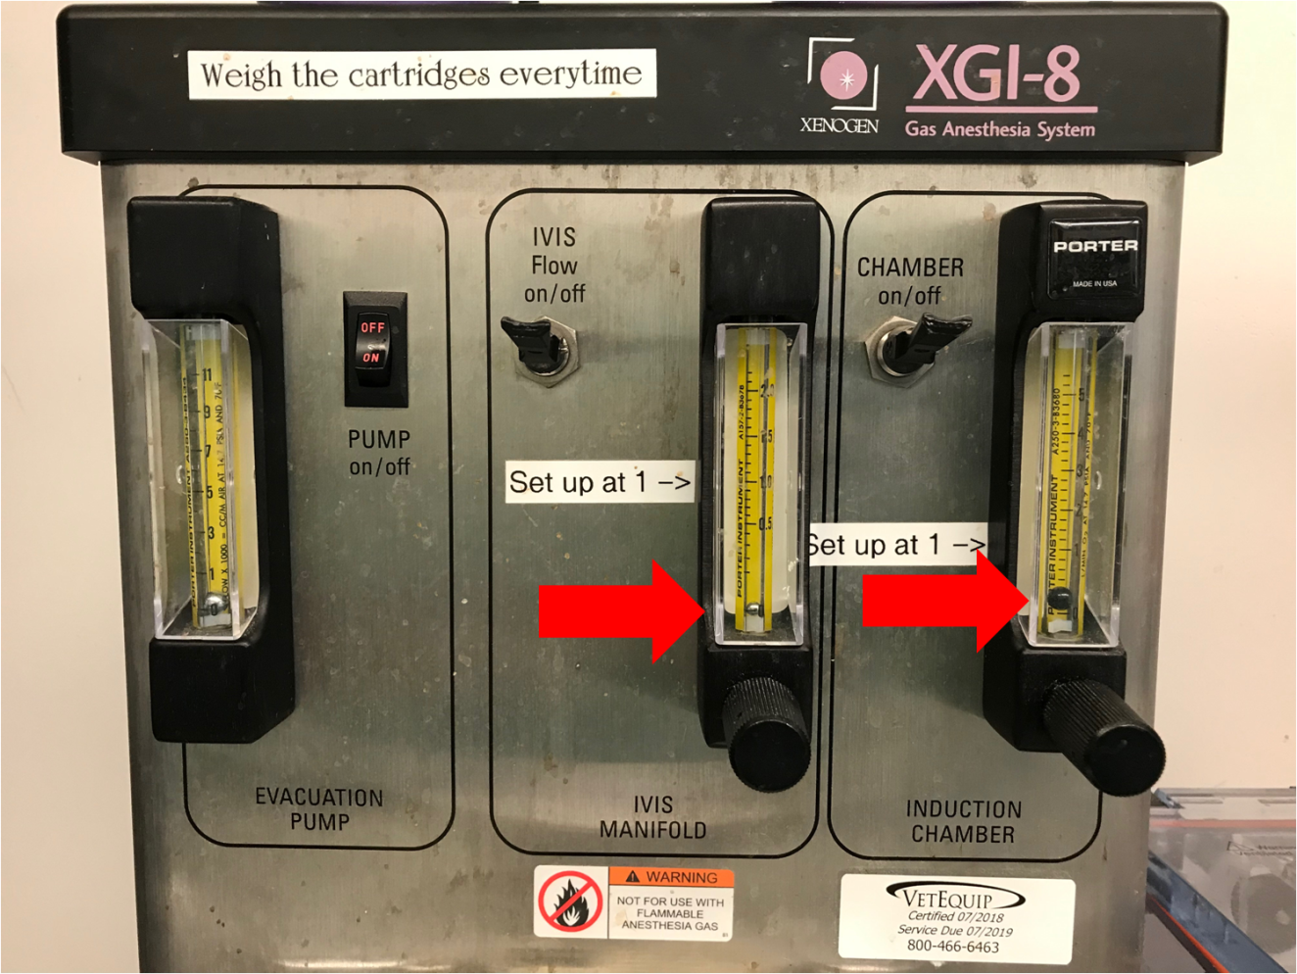

- When the system has been fully depressurized, loosen the knob on the top of the canister in order to open the isoflurane reservoir. Do not open the knob on the bottom of the canister; this will empty all of the iso that is currently in the reservoir onto the floor. It has been closed off and marked with green tape to minimize accidents.
- Connect the isoflurane filling attachment to the iso bottle. Make sure the attachment is screwed on tightly to minimize leaks. Remove the metal stopper from the filling port and insert the filling attachment into the port.Tighten the top knob on the canister so it doesn’t leak while filling the reservoir. The window on the bottom left of the reservoir shows the fill level of the isoflurane. The isoflurane meniscus should be cutting half way through the white triangle in the top of the window.
Check Iso level here.
DO NOT OPEN!
Open this knob to fill.

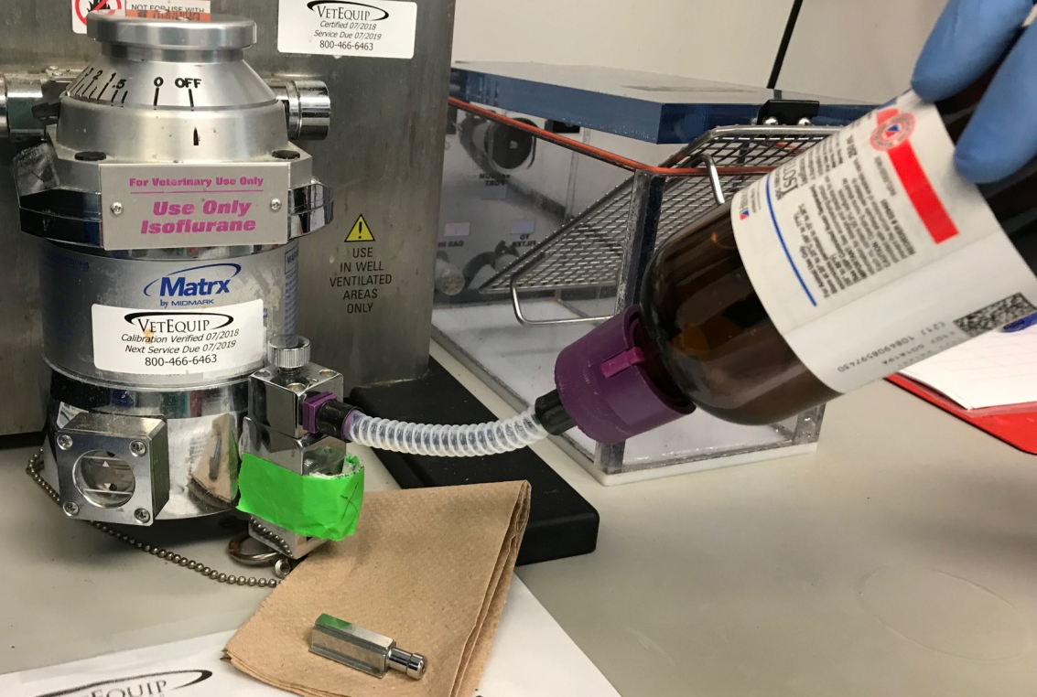

For more information please contact the BIDC – bidc@ucsf.edu
Safety Tips While Imaging With the IVIS

- During an imaging session with mice, insert nosecones into the isoflurane flow ports to direct the isoflurane to the mouse.
- Plug all unused isoflurane flow ports with rubber plugs to block flow of isoflurane. This will reduce the amount of isoflurane filling the IVIS imaging chamber which will reduce user exposure when exchanging mice.

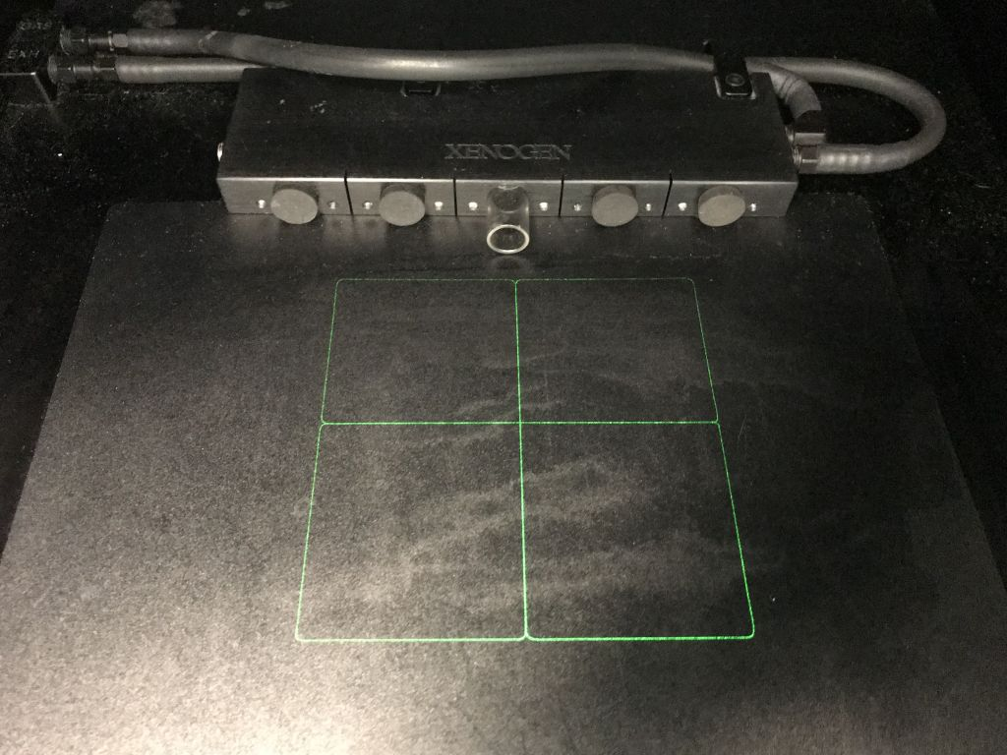
Nose Cone
Rubber Port Plug

- Flush the IVIS imaging chamber and the induction chamber with Oxygen before opening. This will reduce the amount of isoflurane in the chambers when exchanging mice or cleaning.

For more information please contact the BIDC – bidc@ucsf.edu

